## Higher National Diploma in Information Technology

**Object Oriented Programming**

**Lab Sheet 01**

**Java**

**Java is a simple, portable, distributed, robust, secure, dynamic, architecture neutral, object oriented programming language**. It was developed by Sun Microsystems. This technology allows the software designed and developed once for an idealized ‘virtual machine’ and run on various computing platforms.

## Java Virtual Machine

**What is the Java Virtual Machine? What is its role?**

Java was designed with a concept of ‘write once and run everywhere’. Java Virtual Machine plays the central role in this concept. The JVM is the environment in which Java programs execute. It is software that is implemented on top of real hardware and operating system. When the source code (.java files) is compiled, it is translated into byte codes and then placed into (.class) files. The JVM executes these byte codes. So Java byte codes can be thought of as the machine language of the JVM. A JVM can either interpret the byte code one instruction at a time or the byte code can be compiled further for the real microprocessor using what is called a just-in-time compiler. The JVM must be implemented on a particular platform before compiled programs can run on that platform.

**JAVA PROGRAMING TIPS**

* Java is case sensitive language.
* You can use Note pad to write java program.
* You should follow the indentation when your write the program.
* Save your program with “.java” extension.
* Compile the file from DOS prompt

Eg:- c:\javacode\labsheet1> javac <file name with extension>

* If you are successful compile, result in creation of “.Class” containing byte code
* Execute the file (Run file

C:\javacode\labsheet1> java <file name without extension>

* Overall procedure of compile and run java program

<File name.java> 🡪Compile 🡪 Byte code 🡪Run 🡪 Output

1. Write a simple program to display “hello world”?
2. Write program to get following output?

******************************

****** THIS IS MY FIRST *******

****** JAVA PROGRAM ********

*******************************

1. The following program contains 11 errors! What are they?

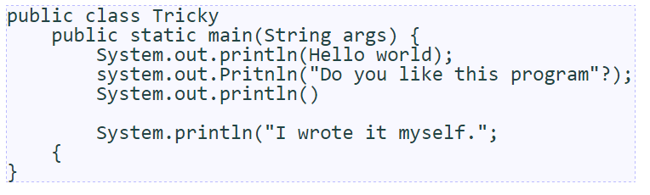

1. Indentation

Programs should be indented properly to make them easier to read.

* { brace → increase indent of following lines by one tab
* } brace → decrease indent of that line and following lines by one tab

The following program has poor indentation. fix it.

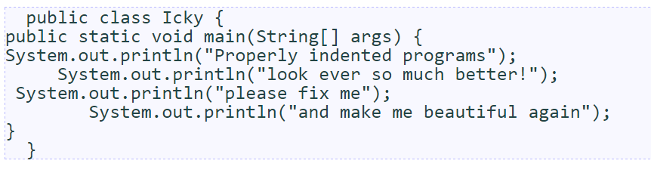

1. What is the output?

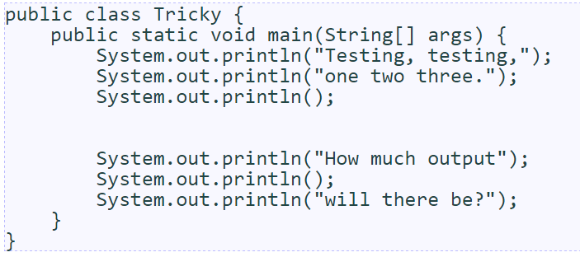

1. Exploring Syntax errors.

Discover what error messages the compiler produces when you make each of the following mistakes. How many unique error messages are you able to cause the compiler to produce?

* Naming your file incorrectly, then compiling.
* Forgetting a keyword such as void or class
* Forgetting a quotation mark "
* Forgetting a parenthesis ( or )
* Forgetting a dot .
* Using too many or too few braces { or }

Notice that the error messages don't always make it obvious what is wrong. But they usually tell you the right line number to fix.